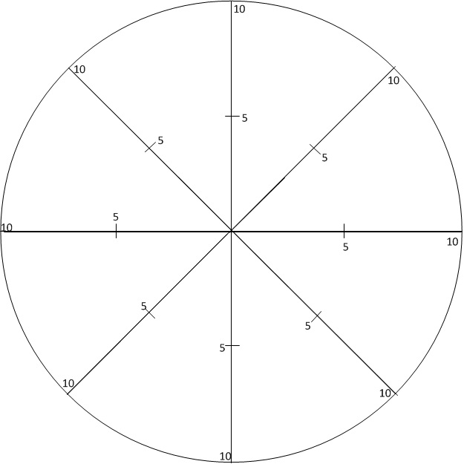
Insert Text
Insert Text
Insert Text
Insert Text
Insert Text
Insert Text
Insert Text
Insert Text
Business Wheel
The Business Wheel Guide
The business wheel is intended as an aid for an individual (Wheel of Life) or against a business to segment how the life or business looks at this moment in time. The segments are limited so it is important when completing the wheel to consider the areas of your business that you would most like to improve. Typical examples could be, Customers, Profitability, Competitive, Marketing etc
At the beginning of the coaching process there will be an induction session which aims to understand what the client is trying to achieve in the long term, their main goal. This will then be broken down into a series of journey goals which may be broken down into one or more session goals. The topics on the wheel will be used to guide this process.

How to complete the wheel:

The eight sections in the Wheel of Life represent different aspects of your life or business. Seeing the centre of the wheel as 0 and the outer edges as 10, for each segment:

- Rank your level of satisfaction with each life area by marking the point between 0 and 10 on the axis of that segment.

- Once they have all be marked then join the marks by drawing lines between them. Do not worry about it being artistic or how it particularly looks.

- The new perimeter represents the wheel of your life. If this were a real wheel, how bumpy would the ride be?

Next Steps:
Once you have completed the wheel and joined all the points the wheel you are now faced with may be of a different shape. Considering each of the segments in turn in any order you choose; think about:
- How does each of the segments affect each other?

- Which segments are the most urgent for you to change or bring the most benefit?

- Which is the highest priority to start on?

